EJC EXAMPLE 4
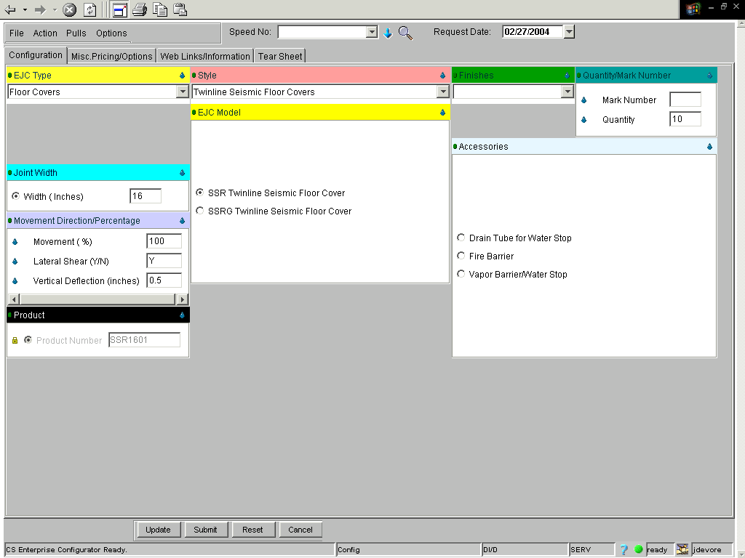
If done correctly, your price will equal $1,694.70.

